PANER, Luke Eleazar R.

PRESTADO, Kyle Ross T.

2ECE-A

**Problem 1 Python:**

**Code:**

import matplotlib.pyplot as plt

import numpy as np

f=np.arange(0,100)

for n in range(0,100):

if f[n]<=9:

f[n]=(f[n]**2)-7

elif f[n]>=10:

f[n]=f[n-10]

plt.stem(f,use_line_collection=True)

plt.show()

plt.figure()

plt.xlabel('x-axis')

plt.ylabel('y-axis')

plt.title('Problem 1')

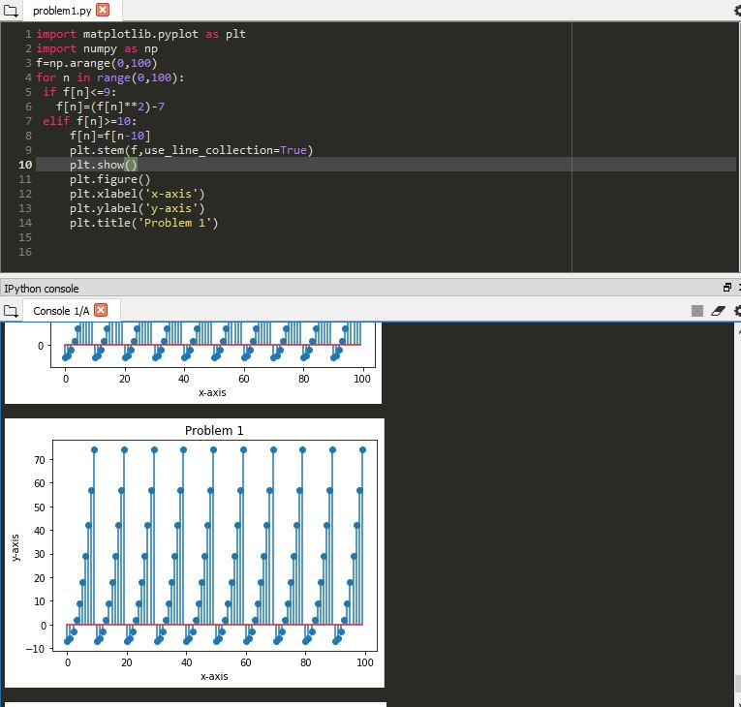

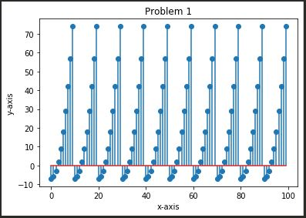

Description:

The Python program displayed a periodical and repeating graph. The command stem will display ‘f’ along the x-axis that scale from the range of ‘f’ with the conditions of f(n).